PREPARATORY COMMITTEE OEA/Ser.P
AG/CP/INF.757/21 add. 5
Fifty-first regular session 30 March 2021
Original: English

NOTE FROM THE PERMANENT MISSION OF THE UNITED STATES PRESENTING THE CANDIDACY OF MS. ALEXANDRA HUNEEUS, J.D., Ph.D, FOR THE POSITION OF COMMISSIONER ON THE INTER-AMERICAN COMMISSION ON HUMAN RIGHTS FOR THE 2022-2025 TERM, IN ELECTIONS TO BE HELD DURING THE FIFTY-FIRST REGULAR SESSION OF THE OAS GENERAL ASSEMBLY

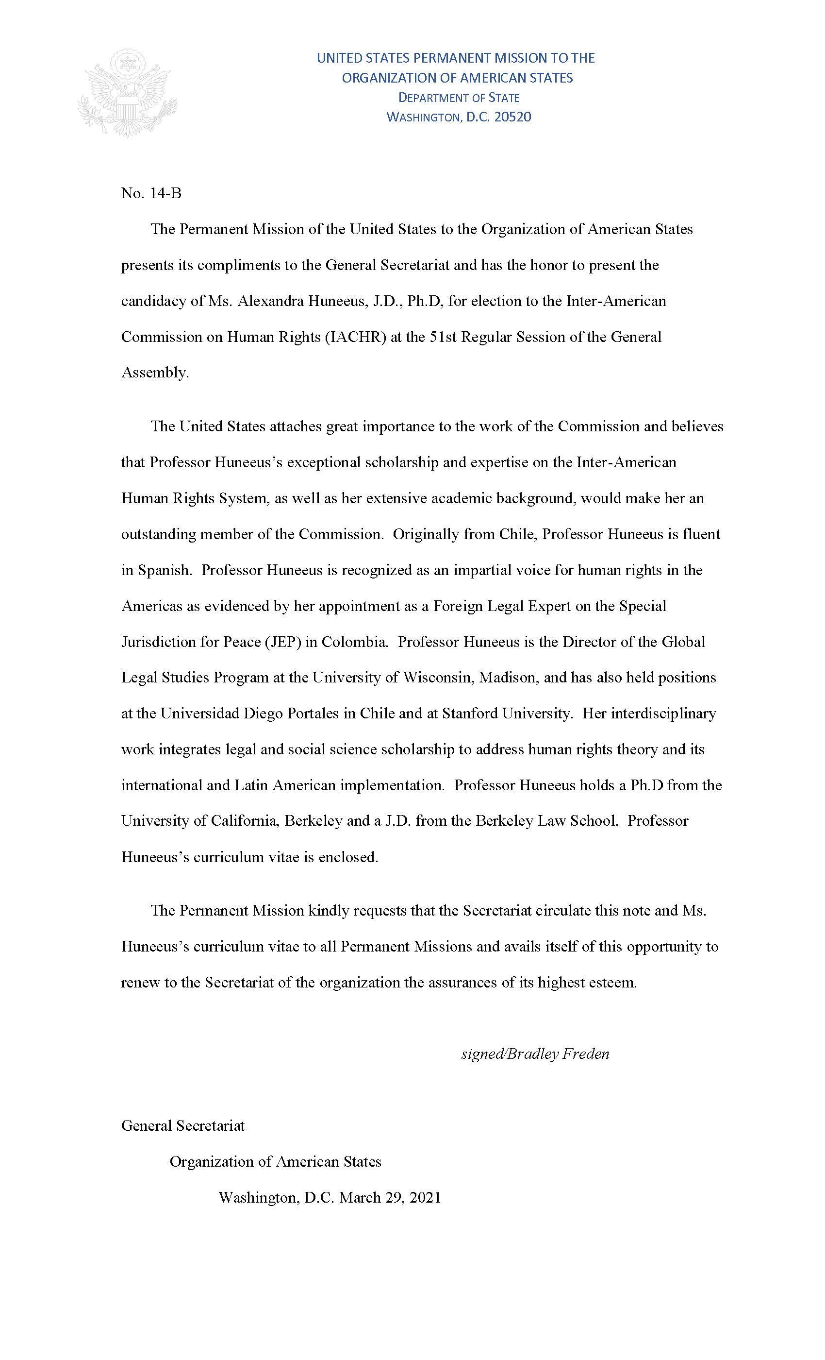
Curriculum Vitae Link

AG08298E01

